Project Design Phase-II
Technology Stack (Architecture & Stack)

Date | 5 feb 2026
Team ID | LTVIP2026TMIDS82001
Project Name | electric motor temperature prediction using machine learning
Maximum Marks | 4 Marks

Technical Architecture:
The Deliverable shall include the architectural diagram as below and the information as per the table1 & table 2
Example: Motor Temperature Prediction using Machine Learning System
Reference: https://developer.ibm.com/patterns/ai-powered-backend-system-for-order-processing-during-pandemics/
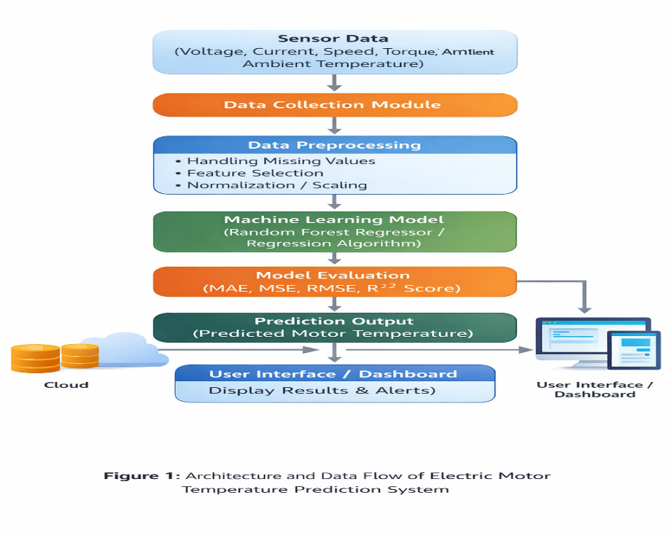
Guidelines:
Include all the processes (As an application logic / Technology Block)
Provide infrastructural demarcation (Local / Cloud)
Indicate external interfaces (third party API’s etc.)
Indicate Data Storage components / services
Indicate interface to machine learning models (if applicable)
Table-1 : Components & Technologies:
S.No | Component | Description | Technology
 | User Interface | Web-based interface where user uploads motor data and views predicted temperature | HTML, CSS, JavaScript, Streamlit / Flask
 | Application Logic-1 | Data preprocessing logic (handling missing values, feature scaling) | Python (Pandas, NumPy, Scikit-learn)
 | Application Logic-2 | Model training and evaluation logic | Scikit-learn (Random Forest Regressor)
 | Application Logic-3 | Prediction logic and model deployment | Flask / Streamlit API
 | Database | Store motor data and prediction results. | MySQL, NoSQL, etc.
 | Cloud Database | Cloud-based storage for model and prediction data | AWS RDS / MongoDB Atlas
 | File Storage | Store dataset CSV files and trained model (.pkl file) | Local File System / AWS S3
 | External API-1 | IoT Sensor API to collect real-time motor data | OpenWeather API
 | External API-2 | Purpose of External API used in the application | Custom REST API
 | Machine Learning Model | Predict motor temperature using regression algorithm | Random Forest Regressor
 | Infrastructure (Server / Cloud) | Application deployment on local system or cloud: | Local, Cloud Foundry, Kubernetes, etc.

Table-2: Application Characteristics:
S.No | Characteristics | Description | Technology
 | Open-Source Frameworks | List the open-source frameworks used | Python, Pandas, NumPy, Scikit-learn, Flask, Streamlit
 | Security Implementations | Data encryption and secure access control mechanisms implemented | HTTPS, SSL/TLS, Role-Based Access Control
 | Scalable Architecture | System designed in modular architecture separating UI, logic, and model layers | Three-Tier Architecture
 | Availability | System can be deployed on cloud for continuous availability | AWS / Azure Cloud Deployment
 | Performance | Optimized model inference time and efficient preprocessing for fast predictions | Scikit-learn Optimization, Caching Mechanism

References:
https://c4model.com/
https://developer.ibm.com/patterns/online-order-processing-system-during-pandemic/
https://www.ibm.com/cloud/architecture
https://aws.amazon.com/architecture
https://medium.com/the-internal-startup/how-to-draw-useful-technical-architecture-diagrams-2d20c9fda90d

